Assignment 4 – DAX & Data Visualization
Calculated Columns:
- Create a Calculated Column for 'Category Type':
Go to ‘New column’ option in home tab to create new column. In the formula bar of the column use concatenation. Here, The formula used ‘ Category type = 'Order Details'[Category] & " " & 'Order Details'[Sub-Category]’

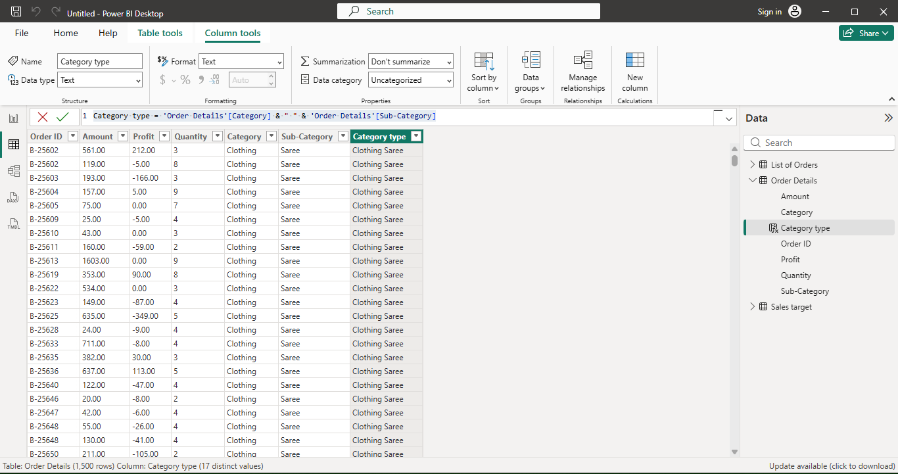
- Calculate Revenue per Order in ‘Order Details’ Table:
Go to ‘New column’ option in home tab to create new column. In the formula bar of the column use the formula ‘Revenue = 'Order Details'[Amount]*'Order Details'[Quantity]’
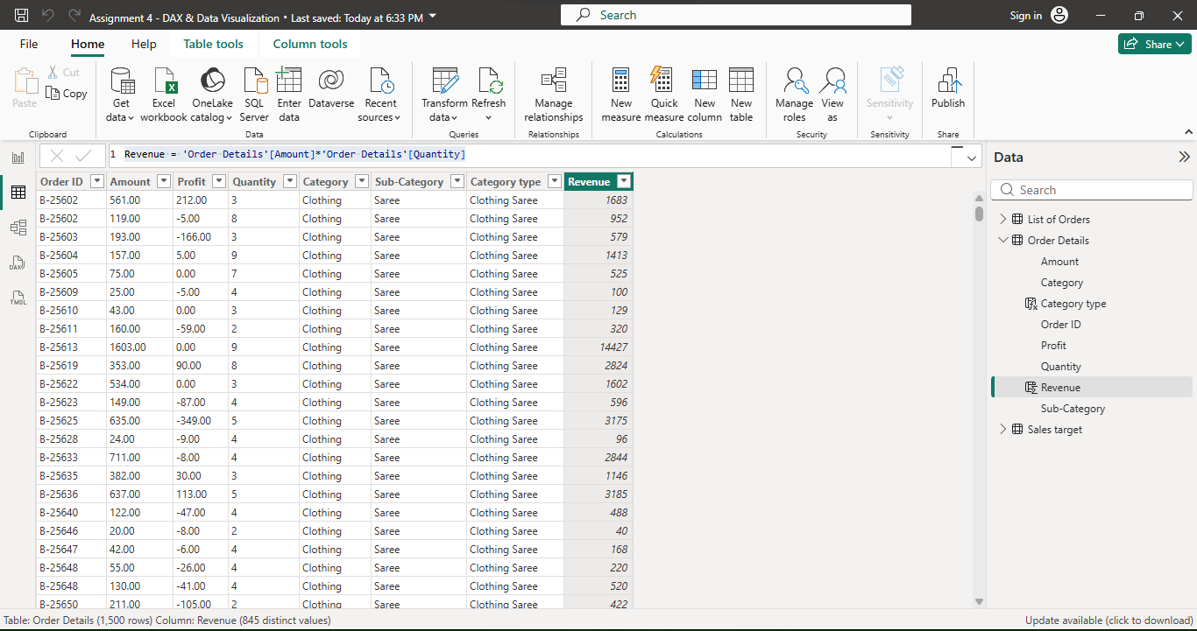
- Create a Calculated Column to Categorize Sales :
Go to ‘New column’ option in home tab to create new column. In the formula bar of the column use the formula ‘Sales Category = if('Order Details'[Amount]>=AVERAGE('Order Details'[Amount]),"Above Average","Below Average")
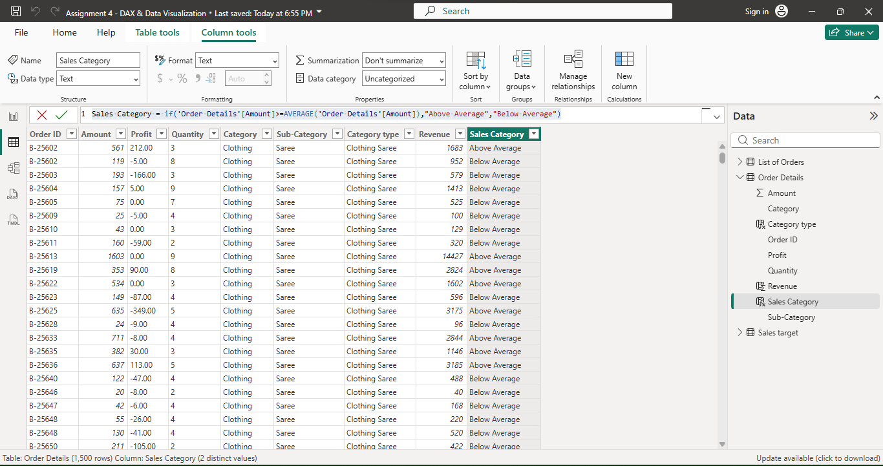
Calculated Measures:
- Calculate Order Count:
Go to ‘New measure’ option in home tab to create new measure. In the formula bar of the measure use the formula ‘ Total Number of orders = COUNT('Order Details'[Order ID])’

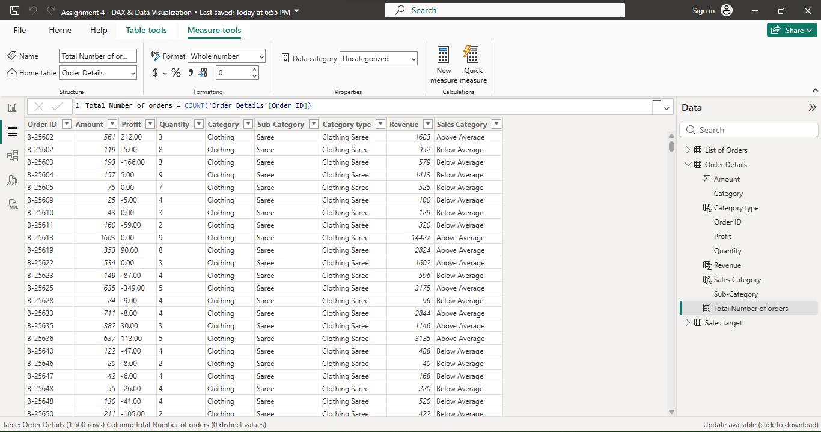

- Calculate Average Profit in Delhi :
Go to ‘New measure’ option in home tab to create new measure. In the formula bar of the measure use the formula ‘Average Profit in delhi = CALCULATE(AVERAGE('Order Details'[Profit]),'List of Orders'[State]="Delhi")’

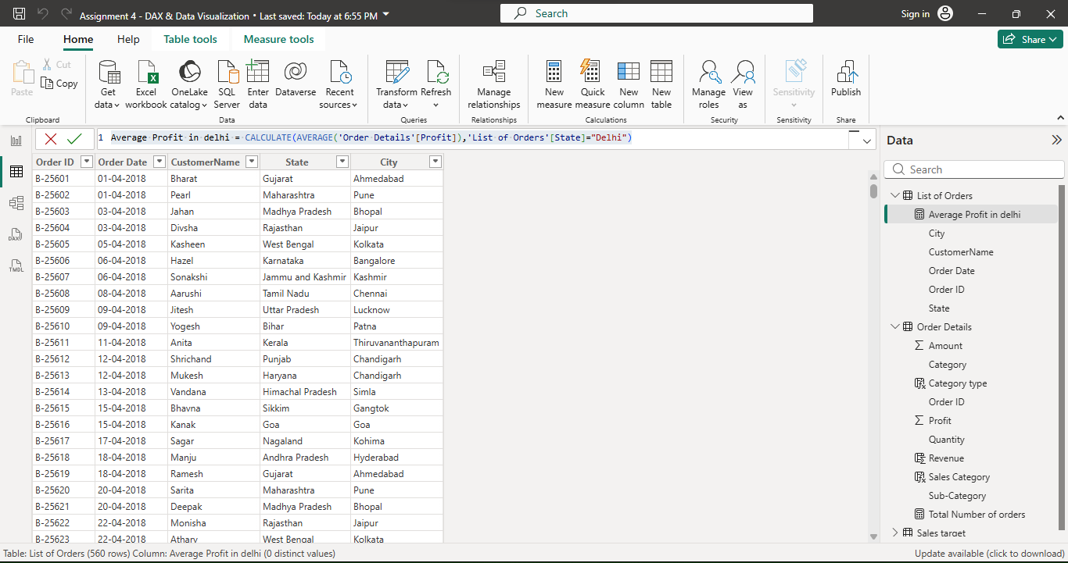
- Calculate Year-to-Date (YTD) Sales :
Create a calendar table consisting of dates, import it to powerbi, Go to ‘New measure’ option in home tab to create new measure. In the formula bar of the measure use the formula ‘sales YTD = TOTALYTD(sum('Order Details'[Amount]),'Calendar'[Date])

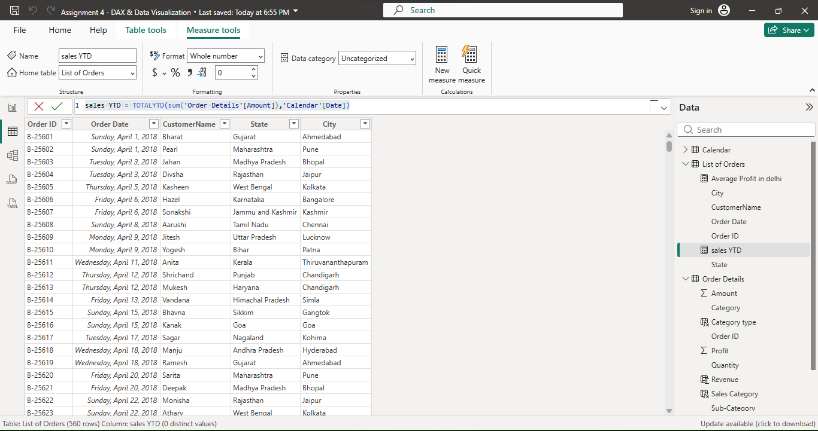
Data Visualization:
- Sales Target Achievement by Category:
In Report view, insert ‘clustered column chart’, on x – axis put ‘category’ and on y- axis put ‘sum of amount’ and ‘sum of target’.

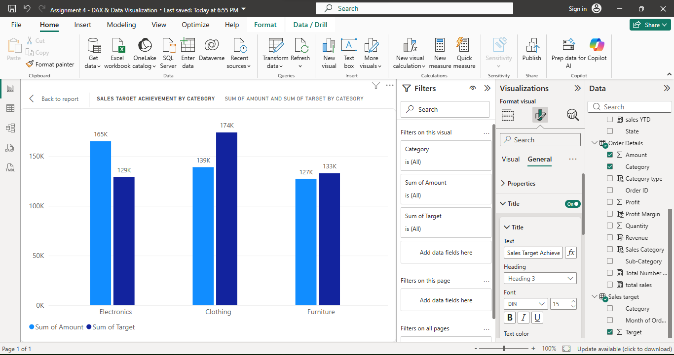
- Max Profit Margin by Sub-Category:
In report view, insert ‘Donut Chart’, On legend put ‘Sub category’ and on value put ‘profit margin’.
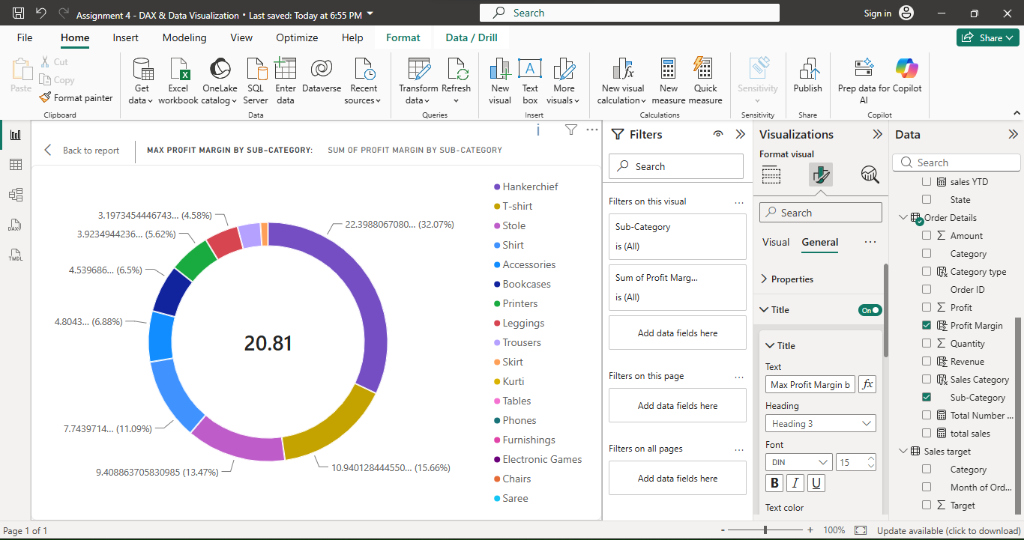

- Monthly Sales Trend:
In Report view, insert ‘Line chart’, on x axis put ‘order date’ expanded and remove day, year and quarter to get only the month and on y axis put amount.

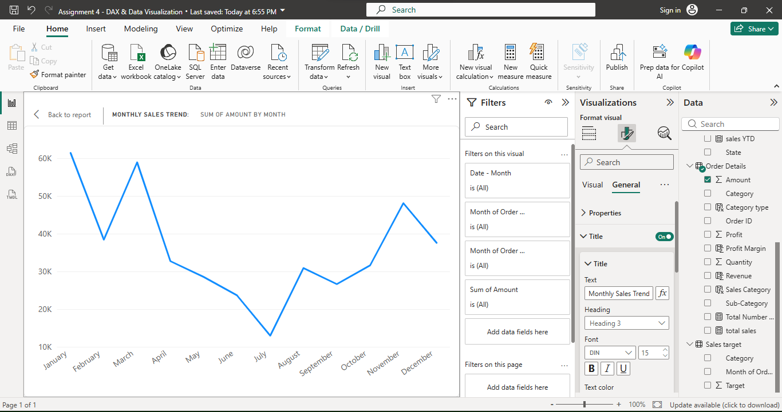
- Comparison of Profit and Quantity by Sub-Category:
In report view, insert ‘scatter chart’, on x - axis put ‘quanity’, on y-axis put ‘profit’ and put ‘sub category’ in legend to get the required scatterchart.

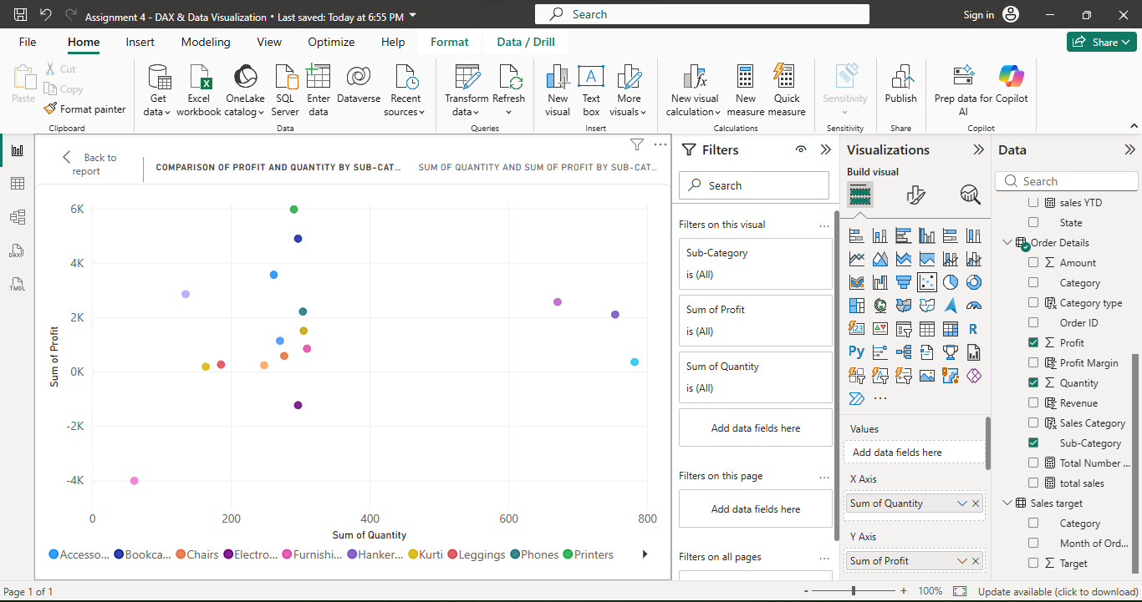
- Comparison of Total Sales Amount and Target :
In report view, insert 2 ‘cards’ and add the ‘total sales’ and ‘total sales target’ measure on values of each card.

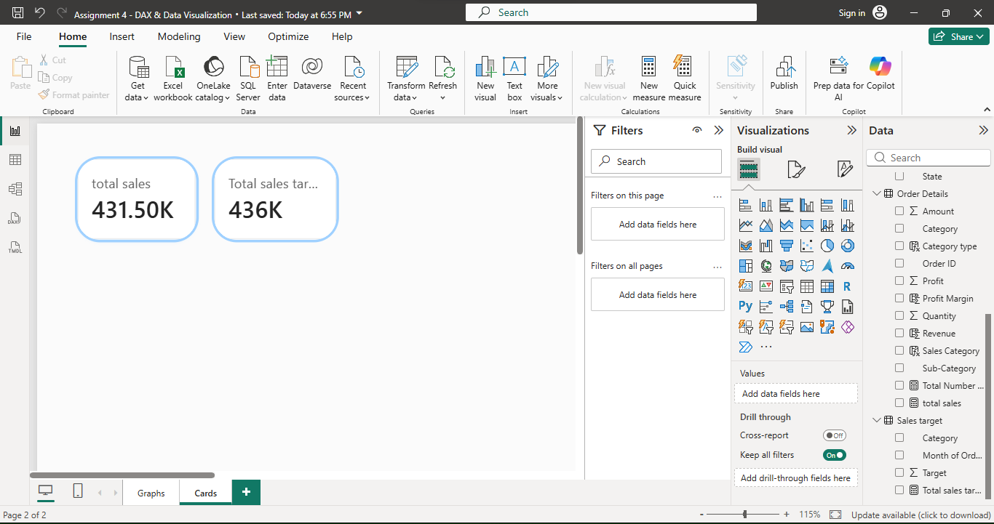
For multirow card to display the minimum target for each segment(category), insert ‘cards’ on category add ‘category’ and in values add measure of ‘minimum sales target’.

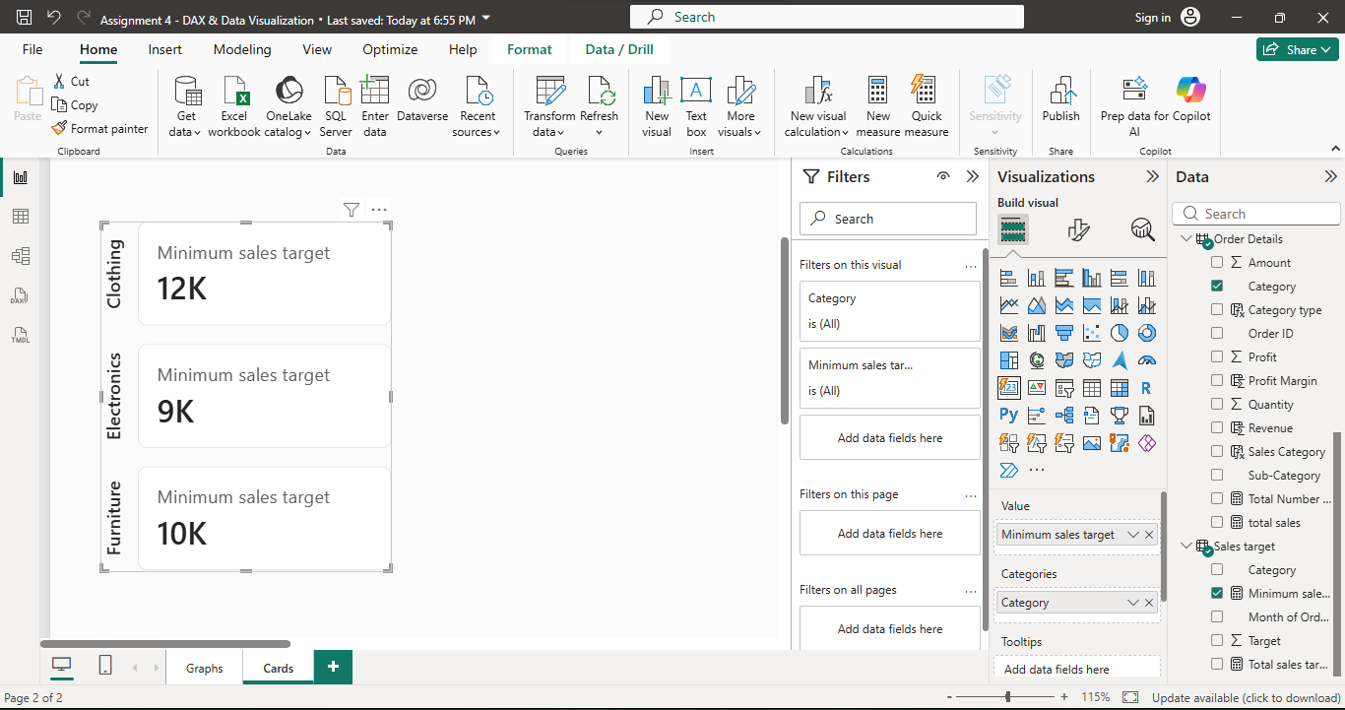
- Sales Performance Matrix:
In report view, insert matrix, put ‘category’ on ‘rows’, ‘months’ on ‘columns’, measure of ‘total sales’ and ‘total sales target’ on ‘values’

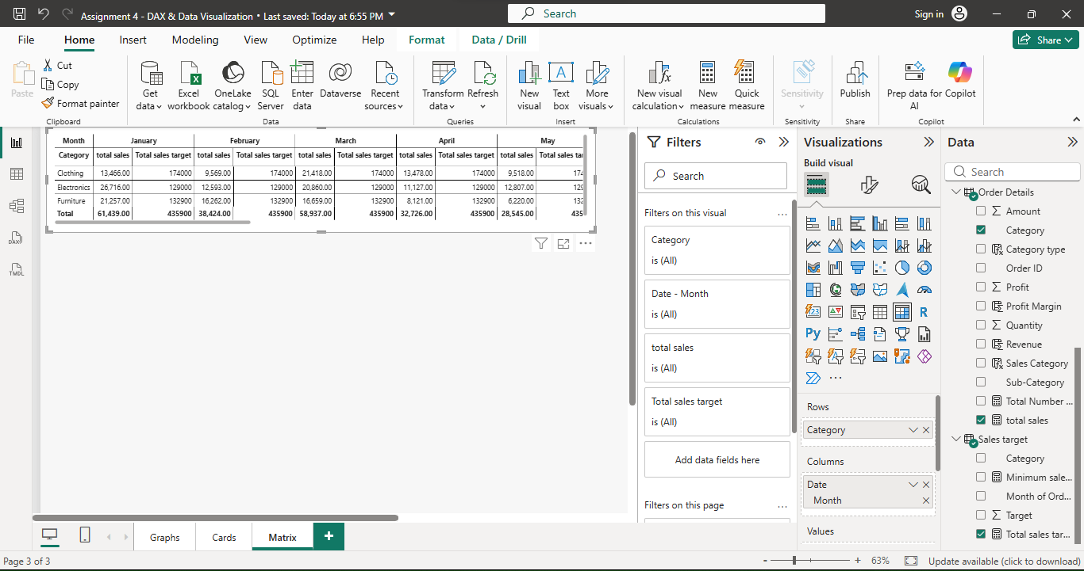
- Geographic Sales Analysis:
In report view, insert map, put ‘city’ on location and ‘total sales’ measure on bubble size.

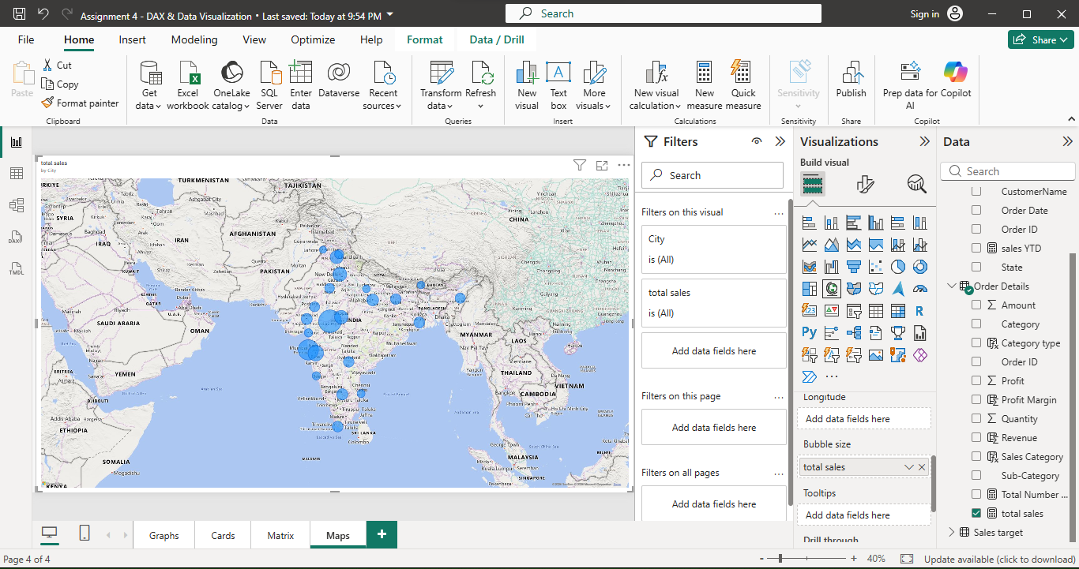
- Sales Distribution by Sub-Category:
In report view, insert ‘treemap’, put ‘sub category’ on category and ‘total sales’ measure on value.

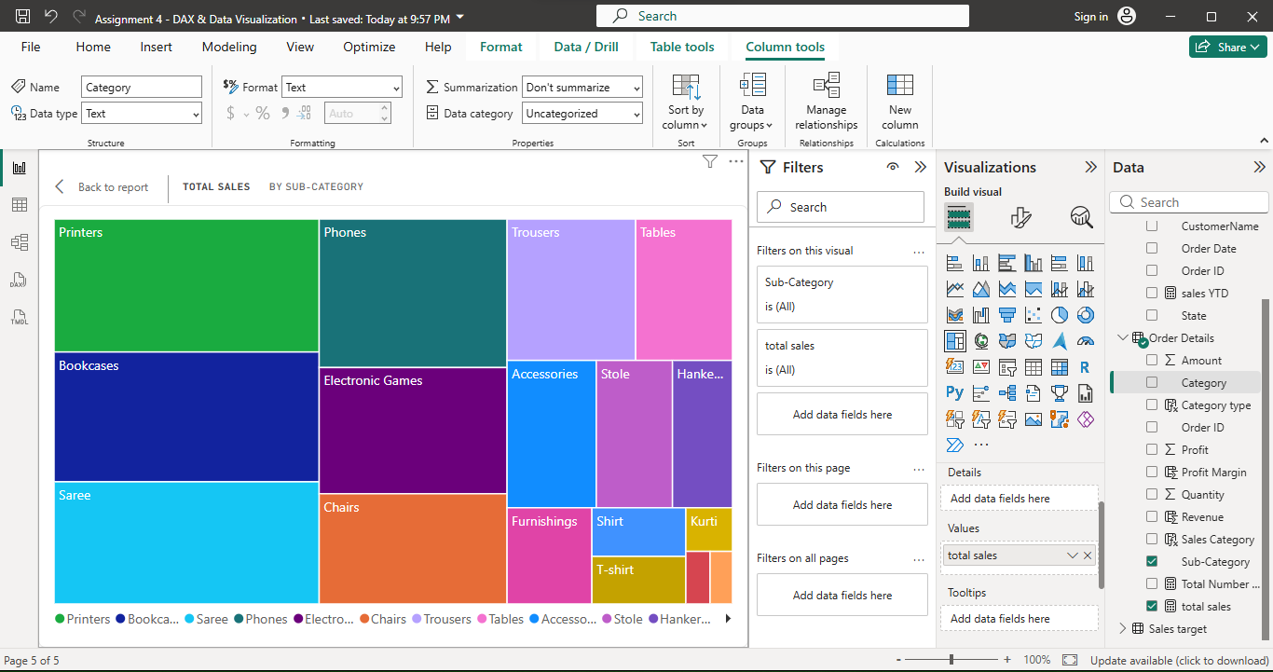
- Order Count Analysis by State:
In report view, insert ‘funnel’ , on category put ‘state’ and on values put ‘Total number of orders measure.

